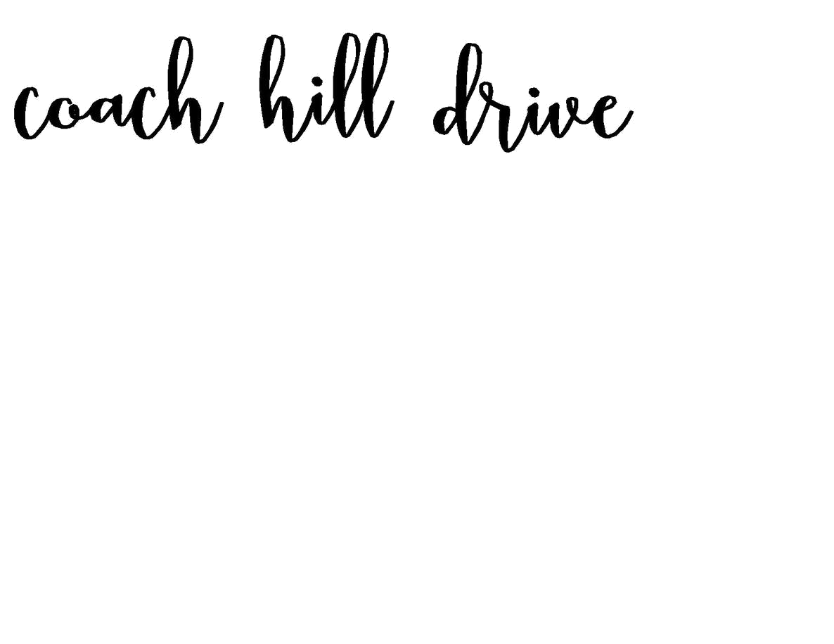

DISCLOSURE STATEMENT
Coach Hill Drive and coachhilldrive.com owns the rights to all original content posted on our site. Any other content featured on our site will be given appropriate credit to the best of our ability. If your content has been featured on coachhilldrive.com and you would like it to be removed or edited, please contact us and we will rectify the situation immediately. Similarly, content from coachhilldrive.com may not be redistributed or sold, and any photos or written content from our site may not be used without our permission in the form of written consent.
coachhilldrive.com may contain paid advertising banners and some merchant affiliate links. An affiliate link means that we may receive a commission on sales of the products that are linked to content on our site. Coach Hill Drive and coachhilldrive.com will only associate with products and brands that we love and that we feel are relevant to our purpose and our values.

